2023 年 AMC 8 真题与解答
American Mathematics Competitions 8 · 中英双语
共 25 题，限时 40 分钟；单项选择题，每题 1 分，答错不扣分，满分 25 分。
内容来源：LIVE by Po-Shen Loh（live.poshenloh.com）历年 AMC 8 真题与解答，试题经美国数学协会（MAA）官方授权使用；本文档由本地整理生成，供个人学习使用，版权归原作者及 MAA 所有。
编排说明：第一部分为题目（先中文、后英文原题），第二部分为解答与答案，便于先做题后对答案。
第一部分 题目
第 1 题
求下列表达式的值：
(8 × 4 + 2) - (8 + 4 × 2)
（A）0 （B）6 （C）10 （D）18 （E）24
English
What is the value of the following expression?
(8 × 4 + 2) - (8 + 4 × 2)
(A) 0 (B) 6 (C) 10 (D) 18 (E) 24
第 2 题
一张正方形纸如下图所示折叠两次，形成四个相等的部分，然后沿虚线剪开。展开后，纸张会匹配下列哪一个图形？

（A）<img src="/amc8/2023/2a.svg" style="max-height: 5rem"/> （B）<img src="/amc8/2023/2b.svg" style="max-height: 5rem"/> （C）<img src="/amc8/2023/2c.svg" style="max-height: 5rem"/> （D）<img src="/amc8/2023/2d.svg" style="max-height: 5rem"/> （E）<img src="/amc8/2023/2e.svg" style="max-height: 5rem"/>
English
A square piece of paper is folded twice into four equal quarters, as shown below, then cut along the dashed line. When unfolded, the paper will match which of the following figures?
(A) <img src="/amc8/2023/2a.svg" style="max-height: 5rem"/> (B) <img src="/amc8/2023/2b.svg" style="max-height: 5rem"/> (C) <img src="/amc8/2023/2c.svg" style="max-height: 5rem"/> (D) <img src="/amc8/2023/2d.svg" style="max-height: 5rem"/> (E) <img src="/amc8/2023/2e.svg" style="max-height: 5rem"/>
第 3 题
<i>风寒温度</i>衡量人在室外有风时感觉到的寒冷程度。风寒温度可用下面的计算式近似：
W=T-0.7· S
其中 W 表示风寒温度，T 表示以华氏度 (°F) 计的气温，S 表示以英里每小时计的风速。
若气温是 36°F，风速是每小时 18 英里，下列哪一项最接近估算出的风寒温度？
（A）18 （B）23 （C）28 （D）32 （E）35
English
<i>Wind chill</i> is a measure of how cold people feel when exposed to wind outside. A good estimate for wind chill can be found using this calculation:
W=T-0.7· S
Here W represents the wind chill, T represents air temperature measured in degrees Fahrenheit (°F), and S represents wind speed measured in miles per hour (mph).
Suppose the air temperature is 36°F and the wind speed is 18 mph. Which of the following is closest to the approximate wind chill?
(A) 18 (B) 23 (C) 28 (D) 32 (E) 35
第 4 题
数字 1 到 49 从中心开始按螺旋形排列在一个正方形网格上。下方网格中已经填入了前几个数字。考虑与数字 7 在同一条对角线上的四个阴影方格中将出现的数字。这四个数字中有多少个是质数？
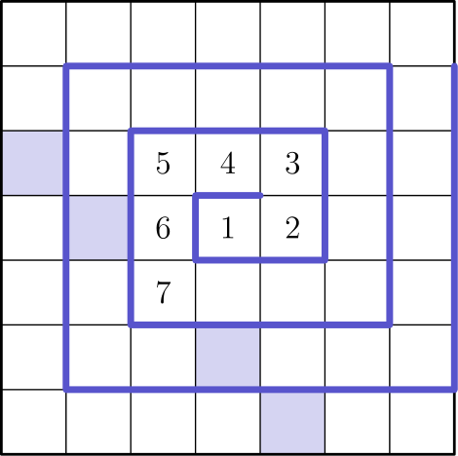
（A）0 （B）1 （C）2 （D）3 （E）4
English
The numbers from 1 to 49 are arranged in a spiral pattern on a square grid, beginning at the center. The first few numbers have been entered into the grid below. Consider the four numbers that will appear in the shaded squares, on the same diagonal as the number 7. How many of these four numbers are prime?
(A) 0 (B) 1 (C) 2 (D) 3 (E) 4
第 5 题
一个湖中有 250 条鳟鱼，还有其他多种鱼。一位海洋生物学家从湖中捕捉并放回 180 条鱼作为样本，其中 30 条被识别为鳟鱼。假设样本中鳟鱼占总鱼数的比例与湖中相同，湖中共有多少条鱼？
（A）1250 （B）1500 （C）1750 （D）1800 （E）2000
English
A lake contains 250 trout, along with a variety of other fish. When a marine biologist catches and releases a sample of 180 fish from the lake, 30 are identified as trout. Assume that the ratio of trout to the total number of fish is the same in both the sample and the lake. How many fish are there in the lake?
(A) 1250 (B) 1500 (C) 1750 (D) 1800 (E) 2000
第 6 题
把数字 2、0、2 和 3 填入下列表达式中，每个方框放一个数字。这个表达式的最大可能值是多少？
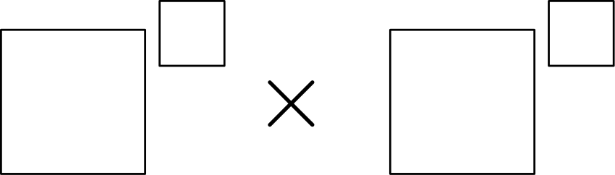
（A）0 （B）8 （C）9 （D）16 （E）18
English
The digits 2, 0, 2, and 3 are placed in the expression below, one digit per box. What is the maximum possible value of the expression?
(A) 0 (B) 8 (C) 9 (D) 16 (E) 18
第 7 题
一个边平行于 x 轴和 y 轴的矩形，其一对相对顶点为 (15, 3) 和 (16, 5)。一条直线经过点 A(0, 0) 和 B(3, 1)。另一条直线经过点 C(0, 10) 和 D(2, 9)。矩形上有多少个点至少在这两条直线之一上？
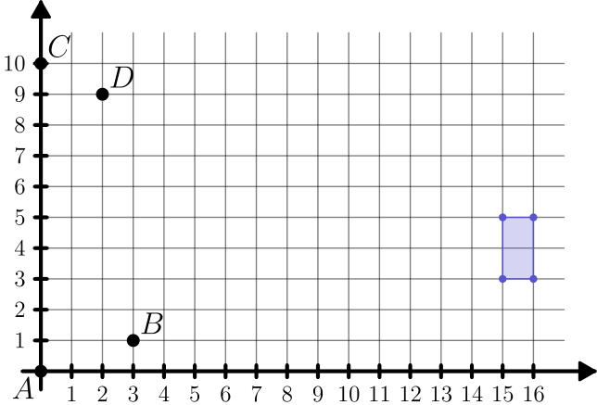
（A）0 （B）1 （C）2 （D）3 （E）4
English
A rectangle, with sides parallel to the x-axis and y-axis, has opposite vertices located at (15, 3) and (16, 5). A line is drawn through points A(0, 0) and B(3, 1). Another line is drawn through points C(0, 10) and D(2, 9). How many points on the rectangle lie on at least one of the two lines?
(A) 0 (B) 1 (C) 2 (D) 3 (E) 4
第 8 题
洛拉、洛洛、蒂娅和蒂约参加乒乓球比赛。每位选手都与另外三位选手各比赛两次。下方显示了选手们的胜负记录。数字 1 和 0 分别表示胜和负。例如，洛拉赢了五场，输了第四场。蒂约的胜负记录是什么？
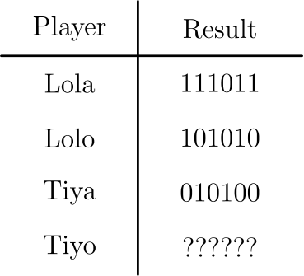
（A）000101 （B）001001 （C）010000 （D）010101 （E）011000
English
Lola, Lolo, Tiya, and Tiyo participated in a ping pong tournament. Each player competed against each of the other three players exactly twice. Shown below are the win-loss records for the players. The numbers 1 and 0 represent a win or loss, respectively. For example, Lola won five matches and lost the fourth match. What was Tiyo’s win-loss record?
(A) 000101 (B) 001001 (C) 010000 (D) 010101 (E) 011000
第 9 题
玛莱卡在山上滑雪。下图显示了她沿雪道滑行时，相对于山脚的海拔高度（米）。她总共有多少秒处在 4 米到 7 米之间的海拔高度？
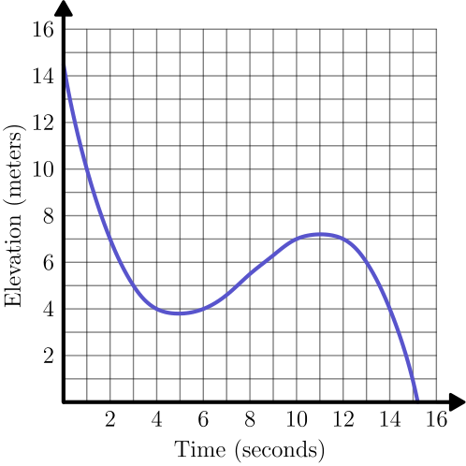
（A）6 （B）8 （C）10 （D）12 （E）14
English
Malaika is skiing on a mountain. The graph below shows her elevation, in meters, above the base of the mountain as she skis along a trail. In total, how many seconds does she spend at an elevation between 4 and 7 meters?
(A) 6 (B) 8 (C) 10 (D) 12 (E) 14
第 10 题
哈罗德做了一个李子派去野餐。他只吃了这个派的 1/4，把剩下的留给朋友。一只驼鹿经过，吃掉了哈罗德留下部分的 1/3。之后，一只豪猪又吃掉了驼鹿留下部分的 1/3。豪猪离开后，原来的派还剩多少？
（A）1/12 （B）1/6 （C）1/4 （D）1/3 （E）5/12
English
Harold made a plum pie to take on a picnic. He was able to eat only 1/4 of the pie, and he left the rest for his friends. A moose came by and ate 1/3 of what Harold left behind. After that, a porcupine ate 1/3 of what the moose left behind. How much of the original pie still remained after the porcupine left?
(A) 1/12 (B) 1/6 (C) 1/4 (D) 1/3 (E) 5/12
第 11 题
NASA 的“毅力号”探测车于 2020 年 7 月 30 日发射。它行进 292,526,838 英里后，约 6.5 个月后降落在火星的杰泽罗陨石坑。下列哪一项最接近探测车的平均星际速度，单位为英里每小时？
（A）6,000 （B）12,000 （C）60,000 （D）120,000 （E）600,000
English
NASA’s Perseverance Rover was launched on July 30, 2020. After traveling 292,526,838 miles, it landed on Mars in Jezero Crater about 6.5 months later. Which of the following is closest to the Rover’s average interplanetary speed in miles per hour?
(A) 6,000 (B) 12,000 (C) 60,000 (D) 120,000 (E) 600,000
第 12 题
下图显示一个大的未涂色圆，内部有若干较小的未涂色圆和阴影圆。大未涂色圆内部的面积中，阴影部分占几分之几？
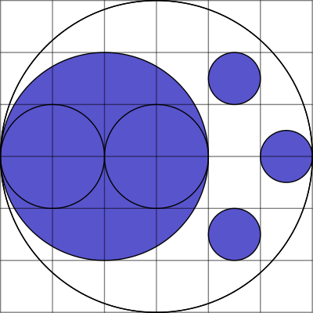
（A）1/4 （B）11/36 （C）1/3 （D）19/36 （E）5/9
English
The figure below shows a large unshaded circle with a number of smaller unshaded and shaded circles in its interior. What fraction of the interior of the large unshaded circle is shaded?
(A) 1/4 (B) 11/36 (C) 1/3 (D) 19/36 (E) 5/9
第 13 题
在自行车赛路线中，起点和终点之间均匀分布着 7 个补水站，如下图所示。另外还有 2 个维修站也均匀分布在起点和终点之间。第 3 个补水站位于第 1 个维修站之后 2 英里处。这场比赛全长多少英里？
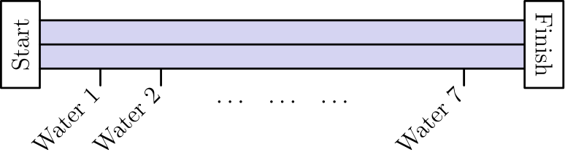
（A）8 （B）16 （C）24 （D）48 （E）96
English
Along the route of a bicycle race, 7 water stations are evenly spaced between the start and finish lines, as shown in the figure below. There are also 2 repair stations evenly spaced between the start and finish lines. The 3rd water station is located 2 miles after the 1st repair station. How long is the race in miles?
(A) 8 (B) 16 (C) 24 (D) 48 (E) 96
第 14 题
尼古拉计划给朋友安东寄一个包裹，安东是集邮爱好者。为了支付邮资，尼古拉想用很多邮票贴满包裹。假设他有 5 分、10 分和 25 分邮票，每种正好 20 张。尼古拉最多能用多少张邮票凑成正好 $7.10 的邮资？
（注意：$7.10 表示 7 美元 10 美分。一美元等于 100 美分。）
（A）45 （B）46 （C）51 （D）54 （E）55
English
Nicolas is planning to send a package to his friend Anton, who is a stamp collector. To pay for the postage, Nicolas would like to cover the package with a large number of stamps. Suppose he has a collection of 5-cent, 10-cent, and 25-cent stamps, with exactly 20 of each type. What is the greatest number of stamps Nicolas can use to make exactly $7.10 in postage?
(Note: The amount $7.10 corresponds to 7 dollars and 10 cents. One dollar is worth 100 cents.)
(A) 45 (B) 46 (C) 51 (D) 54 (E) 55
第 15 题
维斯瓦姆每天步行半英里去学校。他的路线由 10 个等长街区组成，每走一个街区需要 1 分钟。今天，在走了 5 个街区后，维斯瓦姆发现他必须绕路，要走 3 个等长街区而不是一个街区才能到达下一个街角。从他开始绕路时起，他必须以多少英里每小时的速度步行，才能按平常时间到达学校？
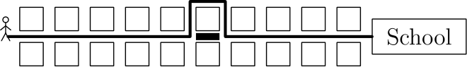
（A）4 （B）4.2 （C）4.5 （D）4.8 （E）5
English
Viswam walks half a mile to get to school each day. His route consists of 10 city blocks of equal length and he takes one minute to walk each block. Today, after walking 5 blocks, Viswam discovers that he has to make a detour, walking 3 blocks of equal length instead of 1 block to reach the next corner. From the time he starts his detour, at what speed, in miles per hour, must Viswam walk in order to arrive at school at his usual time?
(A) 4 (B) 4.2 (C) 4.5 (D) 4.8 (E) 5
第 16 题
字母 P、Q、R 按下图所示的规律填入一个 20 × 20 表格。完成后的表格中会出现多少个 P、Q 和 R？
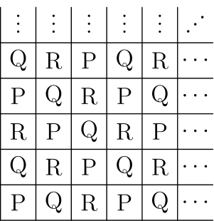
（A）132 个 P，134 个 Q，134 个 R （B）133 个 P，133 个 Q，134 个 R （C）133 个 P，134 个 Q，133 个
R （D）134 个 P，132 个 Q，134 个 R （E）134 个 P，133 个 Q，133 个 R
English
The letters P, Q, and R are entered into a 20 × 20 table according to the pattern shown below. How many Ps, Qs, and Rs will appear in the completed table?
(A) 132 Ps, 134 Qs, 134 Rs (B) 133 Ps, 133 Qs, 134 Rs (C) 133 Ps, 134 Qs, 133
Rs (D) 134 Ps, 132 Qs, 134 Rs (E) 134 Ps, 133 Qs, 133 Rs
第 17 题
一个<i>正八面体</i>有八个等边三角形面，每个顶点处有四个面相交。俊将通过折叠下面这张纸做出图中所示的正八面体。哪个编号的面最终会在阴影区域 Q 的右侧？
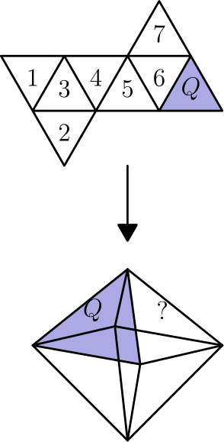
（A）1 （B）2 （C）3 （D）4 （E）5
English
A <i>regular octahedron</i> has eight equilateral triangle faces with four faces meeting at each vertex. Jun will make the regular octahedron shown in the figure by folding the piece of paper below. Which numbered face will end up to the right of the shaded region Q?
(A) 1 (B) 2 (C) 3 (D) 4 (E) 5
第 18 题
蚱蜢格蕾塔坐在池塘中一长排睡莲叶上。从任意一片睡莲叶出发，格蕾塔可以向右跳 5 片，或向左跳 3 片。格蕾塔至少要跳多少次，才能到达从起点向右 2023 片的睡莲叶？
（A）405 （B）407 （C）409 （D）411 （E）413
English
Greta Grasshopper sits on a long line of lily pads in a pond. From any lily pad, Greta can jump 5 pads to the right or 3 pads to the left. What is the fewest number of jumps Greta must make to reach the lily pad located 2023 pads to the right of her starting position?
(A) 405 (B) 407 (C) 409 (D) 411 (E) 413
第 19 题
一个等边三角形放在一个更大的等边三角形内部，使得它们之间的区域可分成三个全等的梯形，如下图所示。内三角形边长是大三角形边长的 2/3。一个梯形的面积与内三角形的面积之比是多少？
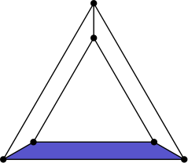
（A）1: 3 （B）3: 8 （C）5: 12 （D）7: 16 （E）4: 9
English
An equilateral triangle is placed inside a larger equilateral triangle so that the region between them can be divided into three congruent trapezoids, as shown below. The side length of the inner triangle is 2/3 the side length of the larger triangle. What is the ratio of the area of one trapezoid to the area of the inner triangle?
(A) 1: 3 (B) 3: 8 (C) 5: 12 (D) 7: 16 (E) 4: 9
第 20 题
在列表 3、3、8、11、28 中插入两个整数，使其极差变为原来的两倍。众数和中位数保持不变。这两个新增数字的和最大可能是多少？
（A）56 （B）57 （C）58 （D）60 （E）61
English
Two integers are inserted into the list 3, 3, 8, 11, 28 to double its range. The mode and median remain unchanged. What is the maximum possible sum of the two additional numbers?
(A) 56 (B) 57 (C) 58 (D) 60 (E) 61
第 21 题
阿丽娜把数字 1、2、⋯、9 分别写在卡片上，每张卡片写一个数。她想把这些卡片分成 3 组，每组 3 张，使每组数字之和相同。有多少种分法？
（A）0 （B）1 （C）2 （D）3 （E）4
English
Alina writes the numbers 1, 2, ⋯, 9 on separate cards, one number per card. She wishes to divide the cards into 3 groups of 3 cards so that the sum of the numbers in each group will be the same. In how many ways can this be done?
(A) 0 (B) 1 (C) 2 (D) 3 (E) 4
第 22 题
在一个正整数序列中，从第三项开始，每一项都是前两项的乘积。该序列的第六项是 4000。第一项是多少？
（A）1 （B）2 （C）4 （D）5 （E）10
English
In a sequence of positive integers, each term after the second is the product of the previous two terms. The sixth term in the sequence is 4000. What is the first term?
(A) 1 (B) 2 (C) 4 (D) 5 (E) 10
第 23 题
一个 3 × 3 网格中的每个小方格随机填入右下方所示 4 种阴影和非阴影瓷砖之一。
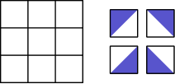
这个铺法在某个较小的 2 × 2 网格中包含一个大的阴影菱形的概率是多少？下面是这样一个铺法示例。
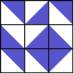
（A）1/1024 （B）1/256 （C）1/64 （D）1/16 （E）1/4
English
Each square in a 3 × 3 grid is randomly filled with one of the 4 shaded-and-unshaded tiles shown below on the right.
What is the probability that the tiling will contain a large shaded diamond in one of the smaller 2 × 2 grids? Below is an example of such a tiling.
(A) 1/1024 (B) 1/256 (C) 1/64 (D) 1/16 (E) 1/4
第 24 题
等腰三角形 ABC 中，AB 和 BC 长度相等。在下面两幅图中，分别画出与 AC 平行的线段，使 △ ABC 的阴影部分面积相同。两个未阴影部分的高分别为 11 和 5 个单位。△ ABC 的高 h 是多少？
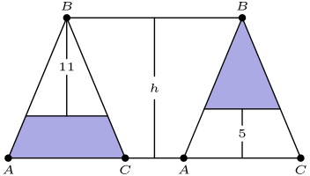
（A）14.6 （B）14.8 （C）15 （D）15.2 （E）15.4
English
Isosceles triangle ABC has equal side lengths AB and BC. In the figures below, segments are drawn parallel to AC so that the shaded portions of △ ABC have the same area. The heights of the two unshaded portions are 11 and 5 units, respectively. What is the height h of △ ABC?
(A) 14.6 (B) 14.8 (C) 15 (D) 15.2 (E) 15.4
第 25 题
十五个整数 a₁、a₂、a₃、⋯、a₁₅ 按顺序排列在数轴上。这些整数等距排列，并满足以下条件：
1 ≤ a₁ ≤ 10，
13 ≤ a₂ ≤ 20，
以及
241 ≤ a₁₅ ≤ 250。
a₁₄ 的各位数字之和是多少？
（A）8 （B）9 （C）10 （D）11 （E）12
English
Fifteen integers a₁, a₂, a₃, ⋯, a₁₅ are arranged in order on a number line. The integers are equally spaced and have the property that
1 ≤ a₁ ≤ 10,
13 ≤ a₂ ≤ 20,
and
241 ≤ a₁₅ ≤ 250.
What is the sum of the digits of a₁₄?
(A) 8 (B) 9 (C) 10 (D) 11 (E) 12

第二部分 解答
答案速查：
题号 1 2 3 4 5 6 7 8 9
答案 D E B D B C B A B
题号 10 11 12 13 14 15 16 17 18
答案 D C B D E B C A D
题号 19 20 21 22 23 24 25
答案 C D C D C A A
答案串：DEBDBCBABDCBDEBCADCDCDCAA
第 1 题 答案 D
可以按运算顺序化简如下。
(32 + 2) - (8 + 8) = 34 - 16 = 18
所以正确答案是 <b>D</b>。
English
We can simplify this as follows.
(32 + 2) - (8 + 8) = 34 - 16 = 18
Thus, <b>D</b> is the correct answer.
第 2 题 答案 E
把剪开后的纸展开，就得到下面的图形。
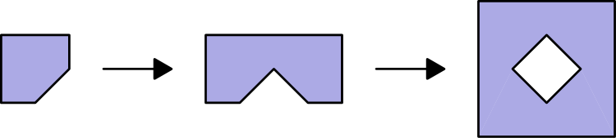
所以正确答案是 <b>E</b>。
English
We can unfold the cut up paper to achieve the following figure.
Thus, <b>E</b> is the correct answer.
第 3 题 答案 B
代入公式，风寒温度为
36 - 0.7 · 18 = 36 - 12.6 =23.4。
最接近的选项是 23。
所以正确答案是 <b>B</b>。
English
Using the formula, the wind chill is
36 - 0.7 · 18 = 36 - 12.6 =23.4.
The closest choice is 23.
Thus, <b>B</b> is the correct answer.
第 4 题 答案 D
把其余的数填进去，就得到完整的网格。
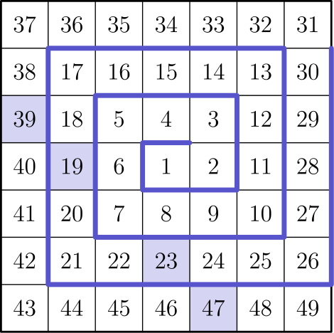
由此可以看出，阴影方格中只有 19、23 和 47 是质数。
所以正确答案是 <b>D</b>。
English
We can fill in the other numbers to get the complete grid.
From this, we can see that the only prime numbers in the shaded boxes are 19, 23, and 47.
Thus, <b>D</b> is the correct answer.
第 5 题 答案 B
样本中鳟鱼比例为 30/180 = 1/6。因此湖中所有鱼数是鳟鱼数的 6 倍。
湖中鱼的总数为 6 · 250 = 1500。
所以正确答案是 <b>B</b>。
English
Note that 30/180 = 1/6. This means that a sixth of the fish in the lake are trout, or in other words, the total number of fish is 6 times the number of trout.
Therefore, there are 6 · 250 = 1500 fish in the lake.
Thus, <b>B</b> is the correct answer.
第 6 题 答案 C
不要把 0 放在底数位置，因为那样会使整个表达式等于 0。
所以 0 必须放在指数位置。指数为 0 的那一项会自动等于 1。
把两个 2 中的一个用于 2⁰，就能把另一个 2 和 3 留给另一项。
另一项可以是 2³ 或 3²。因为 3² 更大，所以取 3²。
于是最大值为 2⁰ × 3² = 1 × 9 = 9。
所以正确答案是 <b>C</b>。
English
Note that we do not want 0 as a base, since that would make the expression equal to 0.
This means that 0 must be an exponent. The number whose exponent is 0 will automatically evaluate to 1.
Using one of the two copies of 2 in the factor 2⁰ leaves 2 and 3 for the other factor.
The other factor can then be 2³ or 3². Since 3² is larger, we use 3².
This gives us a final value of 2⁰ × 3² = 1 × 9 = 9.
Thus, <b>C</b> is the correct answer.
第 7 题 答案 B
画出这两条直线。
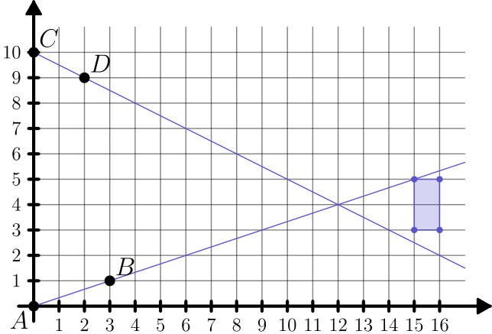
从图中可见，只有矩形左上角落在其中一条直线上。
所以正确答案是 <b>B</b>。
English
We can graph the two lines.
From this, we see that only the top left corner of the rectangle intersects either line.
Thus, <b>B</b> is the correct answer.
第 8 题 答案 A
每一列代表同一轮的两场比赛，因此恰好包含两个胜场记录 1 和两个负场记录 0。
逐列填入使该列达到两个 1 和两个 0 所需的数，得到蒂约的胜负记录为 000101。
所以正确答案是 <b>A</b>。
English
Each column represents one round of two matches, so every column must contain exactly two 1’s and two 0’s.
Completing each column to contain two 1 entries and two 0 entries gives Tiyo’s record 000101.
Thus, <b>A</b> is the correct answer.
第 9 题 答案 B
她第一次达到 7 米是在 2 秒时。
随后她在 4 秒后低于 4 米，这一段贡献 4 - 2 = 2 秒。
接着她在 6 秒时重新高于 4 米，并在 10 秒时再次达到 7 米。
这一段贡献 10 - 6 = 4 秒。最后她在 12 秒时低于 7 米。
再到 14 秒时她低于 4 米，最后一段贡献 14 - 12 = 2 秒。
三个时间段的总长度为 2 + 4 + 2 = 8 所以正确答案是 <b>B</b>。
English
The first time that she hits an elevation of 7 meters is at 2 seconds.
She then dips below 4 meters after 4 seconds. This adds 4 - 2 = 2 seconds to the total answer.
Malaika then goes above 4 meters at 6 seconds. She hits 7 meters again at 10 seconds.
This adds 10 - 6 = 4 more seconds to the total. She finally dips below 7 meters for the last time at 12 seconds.
She then falls below 4 meters at 14 seconds, finally adding 14 - 12 = 2 seconds to the total time.
The desired total is 2 + 4 + 2 = 8 Thus, <b>B</b> is the correct answer.
第 10 题 答案 D
哈罗德把整个派的 1 - 1/4 = 3/4 留给了朋友。
驼鹿吃掉其中 1/3 · 3/4 = 1/4，所以剩下 3/4 - 1/4 = 1/2。
豪猪再吃掉剩余的 1/3 · 1/2 = 1/6，所以最后剩下 1/2 - 1/6 = 1/3。
所以正确答案是 <b>D</b>。
English
Harold left 1 - 1/4 = 3/4 of the pie for his friends.
The moose ate 1/3 · 3/4 = 1/4 of the pie, leaving 3/4 - 1/4 = 1/2 of the pie.
Finally, the porcupine ate 1/3 · 1/2 = 1/6 of the pie. This leaves 1/2 - 1/6 = 1/3 of the pie.
Thus, <b>D</b> is the correct answer.
第 11 题 答案 C
把距离近似为 300,000,000 英里，并把 6.5 个月近似为 30 × 6.5 = 195 ≈ 200 天。
于是每天约行进 300,000,000 ÷ 200 = 1,500,000 英里。
再除以 24，得到约 62,500 英里每小时，最接近 60,000。
所以正确答案是 <b>C</b>。
English
We can round the distance to 300,000,000 miles and approximate 6.5 months as 30 × 6.5 = 195 ≈ 200 days.
This gives 300,000,000 ÷ 200 = 1,500,000 miles per day.
Dividing by 24 gives about 62,500 miles per hour, which is closest to 60,000.
Thus, <b>C</b> is the correct answer.
第 12 题 答案 B
不妨设每个最小圆的半径为 1。
这样有 3 个阴影单位圆，总面积为 3 · 1² π = 3 π。
另外还有一个半径为 4 的阴影圆，其中挖去了两个半径为 2 的未涂色圆。
这部分额外阴影面积为 4² π - 2 · 2² π = 16 π - 8 π = 8 π。
阴影总面积为 8π + 3π = 11π。大未涂色圆的面积为 6²π = 36π。所以所求分数为 11π/36π = 11/36。
所以正确答案是 <b>B</b>。
English
Let each smallest circle have radius 1.
This means that there are 3 shaded unit circles, which total to 3 · 1² π = 3 π area.
There is also a shaded circle with radius 4 with two unshaded circles of radius 2 inside.
This gives us an extra shaded area of 4² π - 2 · 2² π = 16 π - 8 π = 8 π.
The total shaded area is 8π + 3π = 11π. The area of the large unshaded circle is 6²π = 36π. Therefore, the desired fraction is 11π/36π = 11/36.
Thus, <b>B</b> is the correct answer.
第 13 题 答案 D
第 3 个补水站在全程的 3/8 处，因为补水站把全程分成 8 个相等间隔。
第一个维修站在全程的 1/3 处。两站之间的距离占全程的 3/8 - 1/3 = 1/24。这段距离是 2 英里，所以全程为 24 · 2 = 48 英里。
所以正确答案是 <b>D</b>。
English
The 3rd water station is located 3/8 of the way along the race (the water stations split the race up into 8 equal spaces).
The first repair station is located 1/3 of the way along the race. The distance between the stations is 3/8 - 1/3 = 1/24 of the race length. This distance is 2 miles, so the race is 24 · 2 = 48 miles long.
Thus, <b>D</b> is the correct answer.
第 14 题 答案 E
设 a、b、c 分别为 5 分、10 分、25 分邮票的张数，并设 n=a+b+c。金额方程除以 5 得 a+2b+5c=142，所以 n+b+4c=142。
假设 n≥56，则 b+4c≤86。又因为 a=142-2b-5c≤20，所以 2b+5c≥122。合并这两个不等式可得 c≤16，但这样 2b+5c≤2(20)+5(16)=120，矛盾。因此最多只能使用 55 张邮票。
取 a=19、b=19、c=17 时可以达到这个上界： 19(5)+19(10)+17(25)=710。此时邮票总数为 19+19+17=55。
所以正确答案是 <b>E</b>。
English
Let a, b, c be the numbers of 5-, 10-, and 25-cent stamps, and let n=a+b+c. Dividing the value equation by 5 gives a+2b+5c=142, so n+b+4c=142.
Suppose n≥56. Then b+4c≤86. Also a=142-2b-5c≤20, so 2b+5c≥122. Combining these inequalities gives c≤16, but then 2b+5c≤2(20)+5(16)=120, a contradiction. Thus at most 55 stamps can be used.
The bound is attainable with a=19, b=19, c=17: 19(5)+19(10)+17(25)=710. Hence the greatest possible number of stamps is 19+19+17=55.
Thus, <b>E</b> is the correct answer.
第 15 题 答案 B
半英里对应 10 个街区，所以一个街区长 1/2 ÷ 10 = 1/20 英里。
从绕路开始，维斯瓦姆需要走 7 · 1/20 = 7/20 英里。
正常情况下，从这个位置到学校需要 5 分钟。现在他需要在这 5 分钟内走完 7/20 英里。
注意 5 分钟等于 5/60 = 1/12 小时，所以所需速度为 (7/20)/(1/12) = 12 · 7/20 = 21/5 = 4.2 英里每小时。
所以正确答案是 <b>B</b>。
English
If half a mile is the same as 10 blocks, then one block is 1/2 ÷ 10 = 1/20 miles.
Starting from the detour, Viswam has to walk 7 · 1/20 = 7/20 miles.
Normally, from this spot Viswam would take 5 minutes to walk to school. Now he has to travel 7/20 miles in 5 minutes.
Note that 5 minutes is 5/60 = 1/12 hours. This means his speed must be (7/20)/(1/12) = 12 · 7/20 = 21/5 = 4.2 miles per hour.
Thus, <b>B</b> is the correct answer.
第 16 题 答案 C
因为 20 = 3 · 6 + 2，每列底部的 2 个字母会比第三个字母多出现一次。
所以每列中第三个字母出现 6 次，另外 2 个字母各出现 7 次。
在 20 列中，有 7 列的 P 只出现 6 次，其余 13 列中则出现 7 次。R 的情况相同。
因此 P 和 R 都各出现 7·6+13·7=42+91=133 次。
因此 Q 出现了 20 · 20 - 2 · 133 =400 - 266 = 134 次。
所以正确答案是 <b>C</b>。
English
Since 20 = 3 · 6 + 2, the bottom 2 letters in each column will occur one more time than the third letter.
This means that the third letter in each column will occur 6 times, whereas the other 2 will appear 7 times.
Across the 20 columns, P is the letter that appears 6 times in 7 columns and appears 7 times in the other 13 columns. The same is true of R.
Thus P and R each appear 7·6+13·7=42+91=133 times.
Q will therefore appear 20 · 20 - 2 · 133 =400 - 266 = 134 times.
Thus, <b>C</b> is the correct answer.
第 17 题 答案 A
折叠后，编号 2、3、4 和 5 的面形成八面体的下半部分，因此剩余四个面构成上半部分。
候选面是 1、6 和 7。从展开图可以看出，6 会在 Q 的左侧，而 7 又在 6 的左侧。
因此，剩下的面 1 必须在 Q 的右侧。
所以正确答案是 <b>A</b>。
English
Begin by observing that when folded, the faces labelled 2, 3, 4, and 5 form the bottom half of the octahedron. As such, the remaining four faces must make up the top half of the octahedron.
From here, we have narrowed down our possibilities to 1, 6, and 7. We can see that 6 will be the face to the left of the shaded region Q. This also gives us that 7 is to the left of 6.
Therefore, we know that the only remaining face, 1, must be to the right of the shaded region Q.
Thus, <b>A</b> is the correct answer.
第 18 题 答案 D
设向右跳 r 次，向左跳 l 次，则需要 5r-3l=2023。模 5 化简得 -3l≡3pmod5，所以 l≡4pmod5。
为了最少跳跃，取满足条件的最小 l，也就是 l=4。此时 5r-12=2023，所以 r=407。
总跳数为 407+4=411。
所以正确答案是 <b>D</b>。
English
Let r be the number of right jumps and l be the number of left jumps. We need 5r-3l=2023. Reducing modulo 5 gives -3l≡3pmod5, so l≡4pmod5.
To minimize the total number of jumps, use the smallest possible l, namely l=4. Then 5r-12=2023, so r=407.
The fewest number of jumps is 407+4=411.
Thus, <b>D</b> is the correct answer.
第 19 题 答案 C
内三角形边长是大三角形的 2/3，所以面积是大三角形的 (2/3)² = 4/9。
三个梯形总面积是大三角形的 1 - 4/9 = 5/9。
一个梯形面积是大三角形的 5/9 ÷ 3 = 5/27。
它与内三角形的面积比为 (5/27)/(4/9) = 5/27 · 9/4 = 5/12。
所以正确答案是 <b>C</b>。
English
Since the inner triangle’s side length is 2/3 the side length of the outer triangle, its area is (2/3)² = 4/9 the area of the outer triangle.
This means that the three trapezoids are 1 - 4/9 = 5/9 the area of the outer triangle.
Therefore, one trapezoid is 5/9 ÷ 3 = 5/27 the area of the outer triangle.
This makes the ratio of the areas of one trapezoid and the inner triangle (5/27)/(4/9) = 5/27 · 9/4 = 5/12.
Thus, <b>C</b> is the correct answer.
第 20 题 答案 D
原来的极差是 28-3=25，所以新极差必须是 50。要保持中位数为 8，新增的一个数 x 必须小于 8，另一个数 y 必须大于 8。
若 x≥3，最小值仍为 3，所以新的最大值必须是 53。取 x=3 会改变众数，因此 x≤7。所以 x+y≤7+53=60。
若 x<3 且 y>28，则 y-x=50，所以 x+y=2x+50≤54。若 y≤28，最大值仍为 28，这会迫使 x=-22，得到的和更小。因此没有任何情况能超过 60。
取 x=7 和 y=53 时，众数和中位数都不变，极差为 50，所以最大和是 60。
所以正确答案是 <b>D</b>。
English
The original range is 28-3=25, so the new range must be 50. To keep the median 8, one added number x must be less than 8 and the other, y, must be greater than 8.
If x≥3, the minimum remains 3, so the new maximum must be 53. The value x=3 would change the mode, so x≤7. Hence x+y≤7+53=60.
If x<3 and y>28, then y-x=50, so x+y=2x+50≤54. If y≤28, the maximum remains 28, forcing x=-22 and giving an even smaller sum. Therefore no case exceeds 60.
The values x=7 and y=53 preserve the mode and median and give range 50, so the maximum sum is 60.
Thus, <b>D</b> is the correct answer.
第 21 题 答案 C
所有数字的总和为 (9 · 10)/2 = 45，所以每组和必须为 45 ÷ 3 = 15。
含 9 的组中，另外两个数和为 6。可能是 1 和 5，或 2 和 4。
<b>情况 1：</b>一组是 1、5 和 9。
考虑含 8 的那组，另外两个数必须和为 7。唯一选择是 3 和 4。
剩下的一组是 2、6 和 7，其和为 15，所以这种情况给出一种分法。
<b>情况 2：</b>一组是 2、4 和 9。
同理，含 8 的那组另外两个数和为 7。唯一选择是 1 和 6。
最后一组是 3、5 和 7，其和为 15，这又给出一种分法。
所有情况都已检查，共有 2 种分法。
所以正确答案是 <b>C</b>。
English
The sum of all the numbers is (9 · 10)/2 = 45. This means that the sum of each group is 45 ÷ 3 = 15.
Consider the group with 9 in it. The other two numbers must add to 6. Therefore, the other cards in this group are 1 and 5 or 2 and 4.
<b>Case 1:</b> One group is 1, 5, and 9.
Consider the group with 8 in it. The other numbers must add to 7. The only option is 3 and 4 with the remaining cards.
The other group is then 2, 6, and 7. This adds to 15, so this case contributes one possibility.
<b>Case 2:</b> One group is 2, 4, and 9.
Consider the group with 8 in it. As above, the other numbers have to add to 7. The only option is 1 and 6.
The final group is 3, 5, and 7, which adds to 15. This is another configuration.
We have gone through all the cases, which revealed that there are only 2 possible groupings.
Thus, <b>C</b> is the correct answer.
第 22 题 答案 D
设第一项为 x，第二项为 y。
于是，序列的前几项为 x, y, xy, xy², x²y³, x³y⁵, ⋯ 因此 x³y⁵ = 4000。
将 4000 分解质因数，得到 4000 = 2⁵ · 5³。因为 x 和 y 都是正整数，所以能整除 4000 的完全五次方只有 1 和 32。
若 y = 1，则 x³ = 4000，但 4000 不是完全立方数，不可能成立。因此 y⁵ = 32 且 y = 2。
这迫使 x 等于 5。
所以正确答案是 <b>D</b>。
English
Let x be the first term and y be the second.
Then we get the following sequence: x, y, xy, xy², x²y³, x³y⁵, ⋯ Thus x³y⁵ = 4000.
Factoring 4000, gives 4000 = 2⁵ · 5³. Because x and y are positive integers, the only fifth powers that divide 4000 are 1 and 32.
If y = 1, then x³ = 4000, which is impossible because 4000 is not a perfect cube. Therefore, y⁵ = 32 and y = 2.
This forces x to equal 5.
Thus, <b>D</b> is the correct answer.
第 23 题 答案 C
总铺法数为 4⁹。可形成大阴影菱形的 2×2 小网格有 4 个。
选定其中一个 2×2 小网格后，它内部四块瓷砖的方向就被确定了，其余 5 个方格可以任意填。所以每选定一个这样的 2×2 小网格，都对应 4⁵ 种铺法。
两个不同的 2×2 小网格不能同时形成大阴影菱形，因为重叠方格会要求不同方向。因此有利铺法数为 4·4⁵=4⁶。
所求概率为 4⁶/4⁹ = 1/4³ = 1/64。
所以正确答案是 <b>C</b>。
English
There are 4⁹ possible tilings. There are 4 possible 2×2 grids where a large shaded diamond could appear.
After one of these 2×2 grids is chosen, the four tile orientations inside it are forced, and the other 5 squares can be filled in any way. This gives 4⁵ tilings for each chosen 2×2 grid.
Two different 2×2 grids cannot both contain a large shaded diamond, because their overlapping squares would require incompatible tile orientations. Therefore the number of favorable tilings is 4·4⁵=4⁶.
The desired probability is then 4⁶/4⁹ = 1/4³ = 1/64.
Thus, <b>C</b> is the correct answer.
第 24 题 答案 A
设 △ ABC 的面积为 a。左图中的未阴影三角形高为 11，并且与整个三角形相似，所以它的面积是 a(11/h)²。因此，左图的阴影面积是 a(1-(11/h)²)。
右图中的阴影三角形高为 h-5，并且与整个三角形相似，所以它的面积是 a(h-5/h)²。令两图的阴影面积相等，再约去 a，得到 1-(11/h)² =(h-5/h)²。
化简得 h² - 121 = h² - 10h + 25，也就是 10h = 146。
所以 h=14.6。
所以正确答案是 <b>A</b>。
English
Let a be the area of △ ABC. The unshaded triangle in the left figure has height 11 and is similar to the full triangle, so its area is a(11/h)². Therefore, the shaded area there is a(1-(11/h)²).
In the right figure, the shaded triangle has height h-5 and is similar to the full triangle, so its area is a(h-5/h)². Equating the shaded areas and canceling a gives 1-(11/h)² =(h-5/h)².
Simplifying yields h² - 121 = h² - 10h + 25. This simplifies to 10h = 146,
so h=14.6.
Thus, <b>A</b> is the correct answer.
第 25 题 答案 A
设公差为 d。将 a₁ 取其最大可能值 10，将 a₁₅ 取其最小可能值 241，可得 d ≥ (241 - 10)/14 = 16.5。因为所有数都是整数，所以 d 至少为 17。
将 a₁ 取其最小可能值 1，将 a₁₅ 取其最大可能值 250，可得 d ≤ (250 - 1)/14 ≈ 17.8。因为所有数都是整数，所以 d 至多为 17。因此 d=17。
注意 17 · 14 = 238。由于 a₁₅ 至少为 241，所以 a₁ 至少为 3。
另一方面，如果 a₁ 大于 3，那么 a₂=a₁+17 就会大于 20，不符合条件。
所以 a₁ = 3，且 d = 17。于是 a₁₄ = 3 + 13 · 17 = 224。
数字和为 2 + 2 + 4 = 8。
所以正确答案是 <b>A</b>。
English
Let d be the common difference. Using the largest possible value 10 for a₁ and the smallest possible value 241 for a₁₅, we have d ≥ (241 - 10)/14 = 16.5. Since all the numbers are integers, d must be at least 17.
Using the smallest possible value 1 for a₁ and the largest possible value 250 for a₁₅, we have d ≤ (250 - 1)/14 ≈ 17.8. Since all the numbers are integers, d is at most 17. Therefore, d=17.
Note that 17 · 14 = 238. Since a₁₅ is at least 241, a₁ must be at least 3.
On the other hand, if a₁ were greater than 3, then a₂=a₁+17 would be greater than 20, which is not allowed.
Now we know that a₁ = 3 and d = 17. This tells us that a₁₄ = 3 + 13 · 17 = 224.
Therefore, sum of the digits is 2 + 2 + 4 = 8.
Thus, <b>A</b> is the correct answer.

